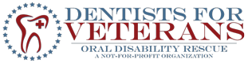

Dr. Charles Zahedi DDS, PhD
Founder, Clinical Director
Dentists for Veterans
18662 MacArthur Blvd., Suite 200
Irvine, CA, 92612
(949) 328-1637
info@dentistsforveterans.org
www.dentistsforveterans.org

November 4, 2016

Mr. Bernard Johnson
President Director
Bernard J. & Mary T. Johnson Family Foundation
842 E. Villa Street, Apartment 207
Pasadena, CA 91101-1280

Dear Mr. Johnson,

This is a letter of inquiry to Bernard J. & Mary T. Johnson Family Foundation requesting its consideration of a grant for $10,000 to provide high quality mobile dental care to up to 150 U.S. veterans who are classified as homeless. As you may know, the vast majority of these veterans do not qualify for dental care through the VA unless they meet extremely limited eligibility criteria.

Introduction: Oral Disability Rescue Takes Action to Make a Difference for U.S. Veterans

The dental needs of homeless veterans are well documented. In surveys listing and ranking the 10 highest unmet needs for homeless veterans, dental care was consistently ranked by homeless veterans as one of their top three unmet needs, along with long-term permanent housing and childcare. Dental problems, such as pain and/or missing teeth can be tremendous barriers in seeking and obtaining employment. Studies have shown that after dental care, veterans report significant improvement in perceived oral health, general health and overall self-esteem, thus, supporting the notion that dental care is an important aspect of the overall concept of homeless rehabilitation. While there is some limited dental eligibility for veterans in VA-sponsored rehabilitation programs, current laws severely limit the eligibility of veterans for comprehensive and sustainable dental care. In fact, there are only the three conditions by which veterans are deemed eligible for any needed dental care: 1) They must be 100% disabled, 2) a former POW, or 3) must have suffered an oral disability during active duty.

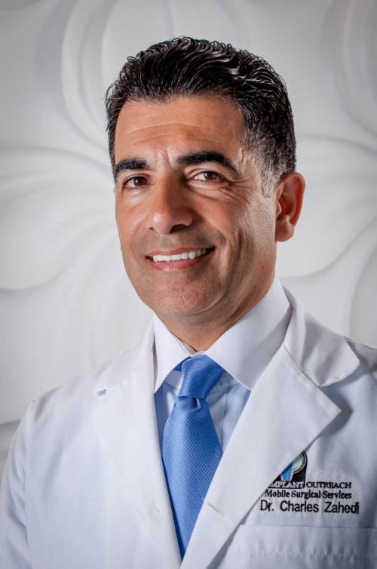
Out of frustration over these limitations, Oral Disability Rescue (ODR) has been formed as a private, not-for-profit organization designed to reach and serve all homeless veterans who do not have the means to afford comprehensive, high quality oral health care. Unfortunately, there is very little peer reviewed literature available on the oral health needs of homeless veterans, especially for understanding how oral disabilities impact other aspects of the veteran’s physical and mental health. Nevertheless, the Dentists for Veterans project has focused on studying this issue and has already provided free dental services to over 40 veterans at its headquarters’ office in Irvine, CA. After learning that too many homeless veterans are unable to come to the Irvine area for treatment, Dr. Charles Zahidi and his team of volunteer dentists and dental assistants have made the historic decision to bring dental services directly to homeless veterans through the operation of a brand new mobile medical clinic. Thanks to a generous donation, ODR has acquired access to a state-of-the art mobile medical clinic including two dental chairs and lab equipment. It has also recruited a team of 10 volunteer dentists and dental assistants who have pledged to provide dental services to homeless veterans free of charge.

Launched in March 2016, this new $650,000 mobile medical clinic is the most visible element of the charity’s Dentists for Veterans project. According to Dr. Zahidi, the primary clinical aim of this project is to identify orally disabled veterans, and to determine how - if at all – their oral disability has affected their cognitive health and overall functionality while at the same time providing them with low to no-cost dental services. The total budget for funding the hard costs of this mobile medical clinic - including fuel, medical supplies, and a driver – for one year is $250,000.
Organization Description

Since commencing on its mission in 2011, Oral Disability Rescue has benefited from the vision, energy and decisiveness of Dr. Charles Zahedi. Dr. Zahedi has been intensively involved with treating and helping maintain the best oral health for older adults, veterans and orally disabled since 1990. He is presently a part-time faculty member at the Department of Periodontics at the University of California, Los Angeles and was once a full-time Associate Professor at the Department of Advanced Periodontics and Implant surgery at Loma Linda University in California from 2002 to 2004. He obtained a Ph.D. in oral medicine with a thesis on the periodontal and bone regeneration. Most of the international publications by Dr. Zahedi deal with treating older adults having advanced bone loss and needing tissue regeneration and dental implants and has written some of the most-read scientific articles on how to make implant dentistry more affordable and predictable.

Dr. Zahedi has trained dentists in many countries, including the United Kingdom, Sweden, France, Italy, Portugal, Belgium, Luxembourg, Poland, Czech Republic, Lithuania, and China.
Over the last six years, the Dentists for Veterans project has attracted numerous volunteer dentists and dental assistants and has fostered a strong track record in providing over $500,000 in free dental care services throughout southern California. Dr. Zahedi is fluent in English, French and Dutch. He is a veteran of the Dutch Air Force and organized medical services as part of the Dutch commitment to NATO. He has a fervent belief in the importance of providing services to our veterans so that we will continue to have a steady supply of war fighters who are willing to put everything on the line to protect our precious freedoms in the U.S. ODRis lead by a volunteer board of directors including a diverse group of individuals with medical, military and community service backgrounds. ODR benefits from a team of 10 volunteer dentists and dental assistants who are prepared to spend their weekends giving back to the community by providing free or low-cost dental services to homeless U.S. veterans.

Statement of Need
It is imperative to remember that there are 364 additional days in the year after every Veteran’s Day, and while a great number of citizens and public officials are very sincere in stating their appreciation to this brave population of service men and women, it is critical that a more concerted approach is taken to ensure our veterans are being properly looked after in some of the most basic and highly essential areas of life. Being able to smile with even the most miniscule semblance of confidence has transformative implications. Whether from a physiological or psychological perspective, it is absolutely clear that dental hygiene and oral wellness play a critical part in the overall health and success of an individual. Stress, anxiety, and depression breed and heighten a lack of confidence and self-worth. Over time this build-up of toxic symptoms is compounded and manifests in potentially life-threatening diseases and illnesses.
In Bad teeth, broken dreams: Lack of dental care keeps many out of jobs, Jonel Aleccia, Senior Writer for NBC News, observes that, “In America, most people – including employers – make instant judgments based on appearance, including someone’s smile and teeth.” For the article Aleccia interviewed Susan Hyde, a dentist and population scientist at the University of California at San Francisco who expounded on the difficulties of adults aspiring to find gainful employment in the workforce: “If you want to portray someone as being wicked, they have missing front teeth. If they’re ignorant, they have buck teeth,” she said. “Even from a very early age, we associate how one presents their oral health with all kinds of biases that reflect some of the social biases that we have.” Lindsey Robinson, a dentist and current president of the California Dental Association, also shared her thoughts with Aleccia, “Those views can prevent potential employers from recognizing potential assets. If they have a job that requires them to interact socially with the public, it’s almost impossible for them to get that job,” she said. “Customer service jobs, good entry-level jobs, they’re not available to people who lack the basic ability to smile, to function, to chew properly”. This article is primarily about the general population, but it is not difficult to see the extended hurdles that our veterans face in the workforce arena in addition to having to deal with existing high unemployment rates and dental care costs.
Considering the trauma some veterans face and struggle with during and after their service to our nation, it should come as no surprise that for successful rehabilitation back into a healthy and productive civilian life, our veterans need to regain, strengthen, and maintain their self-esteem in order to function and fulfill their desired aspirations.
The Methodology

Our project and goals are very clear, to reach as many veterans in need of dental care, and to document any effects oral disability may have on their overall cognitive health and functioning. Our new mobile dental clinic is ready with all necessary equipment and tools which are self-contained. Ideally we want to have two dentists with an assistant each on any given assignment, but a minimum of one dentist will always be present attending to the patients. Led by the expertise of Dr. Zahedi DDS, PhD, we will provide state-of-the-art evaluation criteria and methods to assess oral health care in order to better target the veterans population in urgent need, but also to identify the means by which we can reduce dental treatment costs moving forward. We will identify treatment needs using clinical, radiographic, and luminescence light to aid in detecting early signs of mucosal abnormalities. Using natural tissue fluorescence direct visualization technology to enhance the examination, detection and management of oral soft tissue conditions such as oral cancer will be greatly improved.

Other Funding Sources

We are currently asking for funding from these organizations as well: Ahmanson, Samueli, Henry T. Nicholas III, Parsons and Weingart Foundations.

The Final Summary

ODR would like to give our most sincere thanks to your organization for your consideration. We truly hope that the urgency of this matter is as clear to you as it is to us. There are many ill and affected veterans who feel they may have no other form of recourse but to live in constant pain, marginalized by bureaucracy and empty promises. We should not normalize this pain.

Accordingly, we are requesting a grant of $10,000 to help us stock, supply, fuel and drive the mobile medical clinic over the 2016-2017 fiscal year. If you have any questions about this application, please do not hesitate to call Dr. Zahedi yourself at (949) 922-4450 so that he can explain our project and share his enthusiasm for the good work being done by this non-profit and its exceptional volunteers and donors.

Sincerely,

Edwin Dearborn
Chairman, Board of Directors

P.S. We urgently need your help to capitalize on the recent gift of a mobile medical clinic capable of serving at least 24 homeless veterans per day at remote urban or rural locations in Southern California where there are large populations of potential clients. Please help us make a difference for our veterans and help us document their struggles.

U.S. Department of Veterans Affairs, Office of Dentistry, “About the Homeless Veterans Dental Program,” http://www.va.gov/homeless/dental.asp, Retrieved March 30, 2016.
Vets 101, “VA Dental Services: The Details,” https://www.vets101.org/a/29/d1.aspx. Retrieved March 30, 2016.

