Chapter 5
The Courage of Exploration
The Stories of Captain Cook and Ernest Shackleton
Subjects Covered: Maritime History, The British Empire, Historical Ancedotes

‘’An age will come after many years when the Ocean will loose the chain of things, and a huge land lie revealed; when Tiphys will disclose new worlds and Thule no longer will be ultimate.’’

----- Seneca, Medea

‘’And if there had been more of the world, they would have reached it.’’
------- Cameons, The Lusiads, VII, 14

Captain James Cook (1728-1779) was a lowly non-commissioned officer who became the first person to lead an expedition to the Antarctic. The bright son of a migrant farm laborer from Scotland who had settled in Yorkshire, Cook had only a basic education. At eighteen be was taken as a sea apprentice by a local ship owner who ran a fleet of sturdy coal-carriers known as ‘Collier Barks.’’

After several years of valuable seafaring experience in the rough North Atlantic, Cook was asked to lead an expedition to Tahiti. He had many similarities to Columbus in that he was a skilled astronomer and meteorologist who had a pension for taking on the greatest of challenges. His natural curiosity made him ideal for the discovery of new land with new resources and beautiful scenery.

Traveling with a relatively small cargo, Cook christened his Collier the ‘’Endeavor’’ and set it up for eighteen months on the high seas. Cook’s own journal indicates his excitement about the Natural History yet to be uncovered. In fact, Cook chose a prominent zoologist and botanist to join the crew. Joseph Banks was the most prominent patron of natural history and was destined to become president of the Royal Society. This was a collection of scientists and thinkers who met frequently to share knowledge with one another.

Cook was also conducting a top-secret mission that only he and the royal family of England were aware of. After sailing to Rio De Janiero and around Cape Horn, Cook made it to Tahiti on April 10, 1769. Upon completion of surveying the land, the newly commissioned Cook set about to complete the larger mission, to discover a great southern continent. There was as much interest in proving that such a place did NOT exist as there was in actually finding it! Imagine having to sail forward on a journey of NEGATIVE discovery! This was a task all-in-of-itself. Cook was well-suited for the task as he was restless with energy and a vast knowledge of the seas.

Cook sailed southwestward around the continent of Australia and unknowingly sailed right into the then unknown Great Barrier Reef. The Endeavor quickly took on water and the situation was dire. Cook ordered ballast thrown overboard, and through a combination of skill and luck, the ship began to ride the waters again. However, due to the damage done to the keep of the ship, Cook lost nearly a full month to make repairs on it.

The result was that Cook had to return to England without having proven, or disproven the existence of a southern continent. Now, he was determined to make this a mission of his, and for King George III. His plan was to take the farthest latitude one can take in the southern part of the world. This trip included both possibilities – that a continent was truly there and habitable, or that it was not there at all. If Cook found any part of the mythic continent, he would survey it and have it claimed for Britain and King George.

Now you might find yourself asking what else was happening in England for this to take on such importance. The answer is that King George III was slowly losing bits and pieces of the English empire. The colonial world was coming to an end and King George III was looking to set claims for new land to replace the ones that were being fought over and lost.

Cook returned to Britain with a fantastic array of new specimens. The British Museum was awash with scientists eager to see all of the new and other-worldly things. For his second voyage, Cook decided to honor King George III and to set about to uncover a southern route. To do this, he would take the opposite direction, from Cape Horn towards South America, riding the westerly winds and dipping far enough south to be able to determine if there was indeed a southern continent. The mission was still a secret and Cook ordered all logs to be given to him each day.

The voyage that began in the summer of 1772, would be the longest and one of the greatest ship-sailing voyages in all of history. The trip would tally more than 70,000 miles for one purpose. This spirit helps to explain the seafaring spirit of subsequent explorers for Britain. He named his ships the Resolution and the Adventure. Four months into the voyage, Cook crossed the Tropic of Capricorn into the far South Atlantic Ocean. It was November and a perfect time to be that far south of the equator.

There was a feeling that the landscape and life of the Arctic might be the same in the Antarctic. All across the Arctic-Circle are peoples who live within the climate. There are geese, salmon, crab and numerous other fish with which to eat. But in the southern hemisphere the animals are less numerous and less edible. Secondly, there are hardly any examples of humans living that far south. Both of these would be a surprise to Cook.

In January, Cook sailed into the Antarctic. The awe- inspiring beauty of the landscape transfixed them. They continued to set sail to the south until crushing ice sheets began to squeeze the ships and crunch them under pressure. He was close to the continent but a heavy fog and wet snow began to impede the ships. He debated with himself as to whether it was all worth it and decided to turn back in what had to be an agonizing and desperate decision. It was as close as he would get to the continent of Antarctica. On his way home he discovered countless other islands including Tonga, New Caledonia, and South Georgia Islands in the Pacific. Just one year before the Americans declared themselves independent from King George III, Cook returned home, a Negative Discoverer who changed the world.
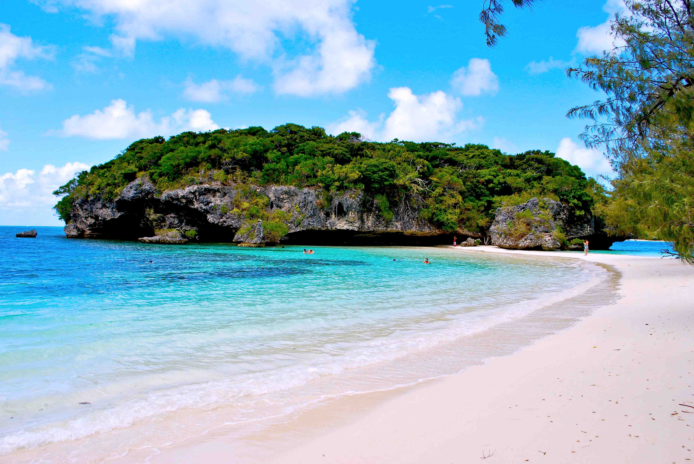
New Caledonia
Ocean Paradise

Within Europe was a growing rivalry of intelligence between Germany and England. Darwin’s breakout book ‘’The Origin of Species’’ came about due to the British sense of adventure and the desire to understand our own origins. It was an exciting time in history to be an explorer, for the sciences of Anthropology, Archaeology, and Paleontology were beginning to take off and were growing in popularity. Throughout the mid 1800s, the British Museum was the largest building in all of Europe. With every ship that returned to England, more and more antiquities and curiosities were brought back to the museum.

By 1840, the museum began to sponsor Archaeology digs throughout the world. The result of these excavations was that the museum continued to grow and grow. By 1900-1930s, the museum saw even more growth with the famous research of Howard Carter, (Egypt excavation) and Leonard Wooley’s spectacular discovery of Ur and the incredible Sumerian tablets.

In 1915, a young boy was looking for stone tools near his missionary home in Ethiopia. His name was Louis Leaky and so began a life-long obsession with human origins. Prior to this time, Professor Jonathan Dart had uncovered the skull of a small child that was older than anything else he had seen. It came from Africa and the brain was smaller than our own. Dart had written about Austripithicus Africanas, the southern most African man. Dart was astonished when his findings were completely rejected. It was the most remarkable discovery of the early 20th century and yet his work wasn’t even included in the earliest textbooks. Dart was not from England, and his ‘’Ape-Man’’ was from Africa, not a prime contender for an Anglo-Specific thinkers of the time.

Leaky found that many of these stone tools were right on the surface. Forty-Four years later, Leaky was in Tanzania looking for our earliest ancestor. He had identified that what separated Ape from Man was the development of stone tools, not the use of already and naturally made tools that chimpanzees use to bust nuts open with. They looked for twenty-two years for a tool-maker, despite the fact they found so many tools.

On a cool morning in 1959, Mary Leaky was walking their dogs when she located the top of a human skull in the dirt. Louis had been sick and had been waiting twenty years before finding the skull. The head-size was smaller than he had expected, found within a bed of tools. He seemed to be in disbelief that the skull was more ape than he had imagined. It had a small brain but its jaws were so large whose muscles were so large they had to be anchored at a ridge.
Just one year later in 1960, a fortunate accident occurred when Mary Leaky’s truck broke down. She got out of the car to check out the scene when she found yet another skull, this one considerably larger. Leaky named it ‘’Homo-Halibas’’ or simply the ‘’Handy Man.’’ Now Leaky had more questions than answers. ‘A second-skull with tools?’ How can that be?
Homo-Halibus had much more human teeth and a larger brain. There is a great mystery in who was co-existing in Africa at the same time. Both fossils date back to 1.8M years of age. The skulls reveal that two hominoids co-existed side-by-side. It also meant that there was more than one line of evolution and multiple lineages of humanity. This completely shook the Germans view of humanity and began to isolate the Lutheran Church .

To see a progression of skulls starting in Tanzania and moving north was a logical. Africanus lived over 2-million years ago and Halibus was 1.3Million years ago. And yet, there had to be more and more bones within the 4Million year old rocks and gullies. Outside of Hadar in Ethiopia, an almost entire skeleton was found. She had been small, maybe only 3.5’’ tall. Australopithecus Africanus, Lucy, would forever change the way we viewed our human story.

Lucy had been a tree dweller but was no longer able swing from trees. She did something no other living species of Ape had done….Walk upright. The ability to walk on two legs was the missing adaption that allowed for survival. Lucy had no defense against animals, but standing upright allowed her to see further than any of her ancestors, giving her a survival mechanism that would allow her to use her hands to make and use tools.

Still, in the early 1900s, we may have found physical proof or our humanity, but we had not found culture or any idea of family. That wouldn’t come until 40,000 years ago with Neanderthals. The ability to organize and develop a plan to hunt down prey is highly sophisticated and wouldn’t show up that far back.

But recently, scientists have examined the DNA of the Neanderthal bones found in 1856 expecting to see a direct lineage between them and us. But what happened next was truly astonishing. The DNA of Neanderthals was drastically different than our own. This implies that there are two completely separate species of Hominoids out of one completely unique evolutionary tree. When Neanderthals died out due to the rise of Homo-Erectus and Homo-Sapiens, we were left alone, an isolated species of hominoid.

That same British spirit would inspire Ernest Shackleton (1874-1922) and it would lead to one of the most inspirational stories history has ever recorded.

Ernest Shackleton was a British subject who decided, as some men do, to transverse the South Pole, going from one ocean to another by crossing the entire continent entirely. Almost everyone thought it to be a foolish venture which would accomplish little, something Shackleton actually agreed with. Yet he was determined to exorcize some personal demons of failure in order to make this happen.

The year was 1914 and Europe was on the verge of World War I. Britain was fighting to remain masters of the open seas. Like King George III before him, Britain was fighting for its own empire. As he prepared for this trip, he raised a considerable amount of money for the journey despite the fact that Europe was falling apart. Shackleton had two ships commissioned for this trip. One was the Endurance and the other was the Aurora.

Shackleton had some unusual requirements for his crew. The news of this trip drew considerable interests, and over 3,000 applicants came forward. When 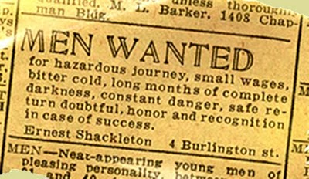interviewing them, he would ask questions regarding whether the men could sing or otherwise entertain. He selected men as much on temperament in addition to technical and navigational abilities. In total, each ship would have 28 men on them for a total of 56. Finally befit of tonnage and men, Ernest Shackleton set forth for his epic journey just six weeks after the first shots of World War I were fired.

Shackleton needed a captain. He chose the exuberance and attitude in Frank Borsely from New Zealand. He was an expert mariner with twenty-five years experience, particularly good at navigating through islands and small channels. While living in London he wandered in to Shakleton’s office and providence couldn’t have been better. Shakleton hired him entirely on instinct.
Shakleton’s plans were ambitious. He would sail to Argentina and then to a whaling station on South Georgia island. After disembarking, he’d make it into the Weddell Sea and then cross Antarctica.
The image conscious Shakleton hired a Public Relations photographer and film maker. He knew that history was being told and he’d wanted to fund future expeditions. Frank Hurley, an Australian, documented the trip in both film and moving images.
They set sail from Buenos Aires on October 26th, 1914 with twenty-six men, two pigs and sixty-nine Canadian Sled Dogs. In eleven days, the Endurance reached a Norwegian whaling station where they stocked two tons of whale meat that would feed both the men and the dogs. The Norwegians warned Shackleton that the ice was not melting as they thought and it had been a much colder summer than they had anticipated. Shakleton had come too far to turn back.
On December 5th, 1914, they left the last place on the planet and headed for Antarctica. At first, the conditions were pleasant. Just three days into the voyage they ran into pack-ice. Shakleton was undeterred. By any rational explanation, the expedition should have ended right there. Why did he persist?
Shakleton was desperate to get away. He was openly having an affair with an American actress which was making life at home very difficult. To make matters worse, his brother, Frank, was implicated in a fraud. Everything at home was difficult.
Shackleton could have played it safe and landed at the first place he saw. He gambled, wanting instead to have a shorter journey across land. And this decision cost the Endurance. Borsely never criticizes Shackleton for pushing forward.
Finally, the ice just completely glued to the ship. The ship was trapped. Being entombed in the ice changed everything. The focus was now on survival.

It was a deeply personal issue for the British explorer. Shackleton was stung by the fact that Robert Amundsen had just reached the farthest point south and there was no longer any notoriety in making this voyage. This was strictly speaking, a self-challenge, something a few rare people do these days. And those he chose to voyage with knew of the peril and furthermore, they knew there was really no gain in this. These men were true adventurers who sought to gain little more than the satisfaction of being able to say that they went and conquered the elements regardless of the odds.

He had left school at 16 and became a cadet on a Northwest Shipping Company, one of the few merchant marine companies still in operation. His status grew because he would essentially do everything that no one else wanted to do. He chose the dirty work, the tough jobs, and earned the respect, the loyalty of men much older than himself. Even as he rose in position, he never forgot where he came from, and even as First-Mate he could be seen cleaning out the bowels of the ships.

Hard work was paying off, but Britain was finding itself beginning to sell the merchant marine ships and equipping them for war. Shackleton became somewhat of a victim in a world filled with dread and worry, which he was powerless to change. Some historians believe his desire to go to the South Pole was to also remove himself geographically from the possibility of having to command a ship at war.

As the ships made their way to the south, everything seemed to go as planned. But on December 5th, the ships encountered pack ice. He was stuck in the ice through the month of February and the temperatures were rapidly dropping. Realizing that his ship was going to be crushed, he ordered his men to abandon ship and they did just that, setting foot on dry land for the first time in 497 days. For two months, the captain and his men camped out on an ice flow. The entire crew was essentially floating on raft made of ice.

Inside History: Wherever possible, explore the newspapers of the era. These offer a day-by-day account of how things evolve and change. It’s History ‘as it happened.’’

I researched newspapers and it was definitely a story, but WWI dominated the front pages and Shackleton was but a sidebar. Nonetheless, Britain was looking for a source of National Pride at a time when its very existence was at risk. The captain took four men with him and told the remaining men that if he didn’t return within four weeks that he was to be assumed dead. His mission was to get to a nautical weather station where he knew he could get help. He gave himself four weeks, which beyond that, he knew everyone would perish. But, he would not

Shakleton’s Maps detailing Ice * Pictures from Shakleton’s Departure * News Accounts as it Happened
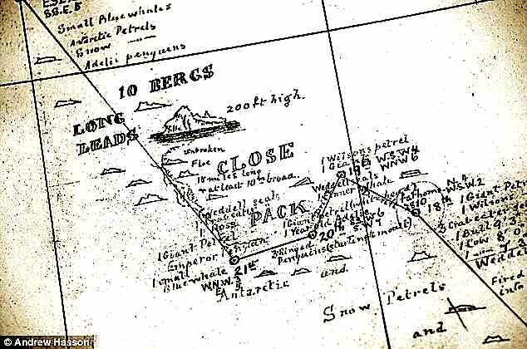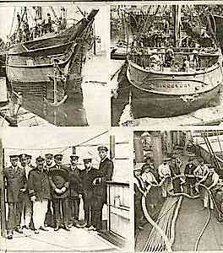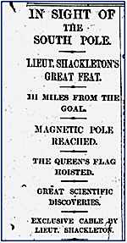

27 men had put their lives in Shackleton’s hands and he wanted to save the men. He had to get Frank Hurley’s pictures back home as well. The life on the ship for a couple of months wasn’t all that bad. The dogs were great companions to these men. Shakleton kept the ship in good shape, and he kept the men in good shape. They were filmed playing soccer and the chef had a knack for cooking penguin, which had just enough vitamin-C to prevent the sailors from getting scurvy.
But after two months, the situation turned serious. Worsley noticed that the ship, while stuck, was still moving in the ice. The Weddell Sea has a current, called a gyre, that was slowly moving the ice. But more and more, the ice built up on the side. Six months went by and it the ship began to tile to the side, causing the wooden ship to bend, buckle and crack. Shakleton was well aware that if they lost the ship they would likely perish.
On October 25, 1915, nearly a year after they left Buenos Aires, the men and the dogs abandoned the ship. The film and the pictures are amazing. The damaged ship had at least provided shelter. Now they were forced to camp on ice flows that cracked beneath them. Worsely wanted to wait for the ice flow to drift toward open water then set off in life boats. Shakleton however wanted to march over three hundred miles to Paulette Island, where he knew there was a weather station.
The journey across land was next to impossible. They went for three days and found themselves within view of the Endurance. Now the idea of floating on an ice-island was the only choice. Then inexplicably, the penguins and seals they had been living off of vanished.
Shackleton then made his most unpopular demand. It was time to shoot the dogs. ‘’I’d have rather shot the best of men than the worst of the dogs.’’ Said one embittered sailor. They watched the ice-packs crack and destroy the Endurance.
On April 9th, the ice began to break up. They were able to get on the three life boats in search of dry land through the waters. They had all the risks of the ice and currents. But Worsley’s experience was the key.
He was forced to navigate from glimpses of the sun through his sextant. The small boat was leaping from wave top to wave top. Imagine – you have to get two good views to see where you are. Worsley realized – after two days that the current had pushed them BACK two hundred miles. Fresh water was now in short supply and they were slowly freezing to death. They now had decided to set sail for a small group of rocks called Elephant Island.

Captain Worsley had been on the helm for forty hours had to be straightened out so he could sleep. The crew had spent fifteen months at sea. Several of the men had given in, and they lost their spirit. But this expedition wouldn’t make landfall the easy way. A brutal storm blew in and they lost sight of the island. Through a stroke of miraculous luck, all twenty-eight men landed safely on Elephant Island.
Most of the island has one-hundred foot ice cliffs, violent winds, and almost no sign of life. The explorers never wanted for someone to look for them. Anything that they were doing was still a better option than going to war. Shackleton and Worsley determined that the winds of any voyage would take them away form the Falklands, which was much closer. A rescue mission was now planned.
Shakleton told the men of the risks. He would go with four other men to make it to St. George’s Island. Everyone wanted to take the trip. Four men were chosen; McNish the Carpenter, John Vincent, Tim McCarthy and Tom Creen.

Worlsey gave it a 10% chance and on April 24th, 1916,the crew set out for a tiny spec of land on the Atlantic ocean. First officer Frank Wylde stayed behind with the men. He was under orders to leave on his own volition whenever he felt there was no return for them. After eight hundred miles of sailing, an island was spotted. It was during this time at sea that Shakleton tells Worlsey that he had no idea how a small boat works, and it gave the two men something worth noting in the ship journal. They had a chance to laugh.
The captain had an uncanny ability at ‘’dead reckoning’’ which is the ability to essentially know where you are. The conditions were so rough that the men could only serve on top of the deck for five minutes at a time. McNish and Vincent were frostbitten and had lost the will to move forward. After thirteen days at sea, they saw birds.
Then, as if by design, the crew battled another brutal storm. The same storm took a 200-ton steamer bringing coal and sunk it. But that wasn’t the fate of this little boat. Worlsey zigged-zagged until the storm finally let up. After traversing the roughest seas on earth in a 22-foot craft in the center of two storms.
Once they landed, they had fresh water and seals. The storm had forced the men to land on the wrong side of the island. Shackleton and Worsley would walk across the island, through uncharted lands. They needed clear weather and a full moon. Nine days after making landfall, three of the five men made their way in the middle of the night. All hopes rested on Shackleton and Worlsey to navigate across ice, mountains and glaciers. They had hammered brass screws into the bottom of their souls which gave them a little grip on the ice. With no tents, there was no option to rest. They kept going. The three men stayed focused and together. Repeatedly they doubled back and retraced their steps. Eventually they climbed atop a huge precipice, a dangerous trip through an unknown valley.
Facing no obvious alternative, the men decided to use their coiled rope as a sled. The three of them bouncing and gaining speed until they finally hit the bottom.
Shackleton wrote, '..the men started cheering and laughing, joyous we were at this very moment, all of our hardships seemed to be forgotten."
They laughed the sled-ride off but now they were utterly driven. The next day, they had run out of kerosene.

At six o’clock, Shackleton thought he heard the whistle of the whaling station. The three men heard the first sound in seventeen months that wasn’t generated by them. The sight of the buildings, and the burden of carrying their lives with them is what kept Shakleton going.

He could have taken a day or two to catch his breath. Certainly no one would have blamed him. But Shakleton wasn’t about to rest now. That very night a ship was outfitted to come and get the men he had left behind. Even though in a steel steamship, the pack ice was too thick. Debate about proceeding to Elephant Island continued. Shackleton would hear nothing of it. More determined than ever to get them after four months, there was no turning back. Worsley looked through his binoculars and saw the men on the island, ALL twenty-two of them.

Shakleton would make several world navigations before dying on St. George’s Island. Frank Worsley ended up becoming a war hero and then traveled the globe giving lectures before dying in 1943.

The men made it and were able to summons a ship from Argentina to rescue the men. All but three men made it back to England alive. For his courage, Shackleton was made into a Knight of the British Empire. Later, he would petition Argentina and Chile to join the war on behalf of the allies. But the personal lessons in this great piece of history are many.

When you are faced with the most incredible of challenges, when you are looking at obstacles in your way to success, when you find yourself a little short on determination and a little short on passion (which happens to us all) then let this be your inspiration: Take your closest and most trusted of friends by their hands, and slide down that mountain and laugh and find your joy along the way..........Because in the end, when it all matters the most, these moments will be the ones that carry us through and help see the life we lead with the perspective we perhaps should have had all along!

The quest to uncover new worlds and meet new people and take on new challenges is something very close to me. The age of discovery, whether it is on this planet or in space, is an exciting prospect for a historian. I find inspiration in the courage and the effort made in order to be the ‘first’ at anything. Perhaps that is one of the reasons that in my life, I have chosen to visit some of the most remote places on the earth. There is something incredible about feeling as if you are walking in a place where few humans have ever stepped foot. But friendships are everything along the way in our journey through life, and I have to ask, what is it that you not only share your trials and tribulations with your friend, but you share your moments of joy as well? ###

